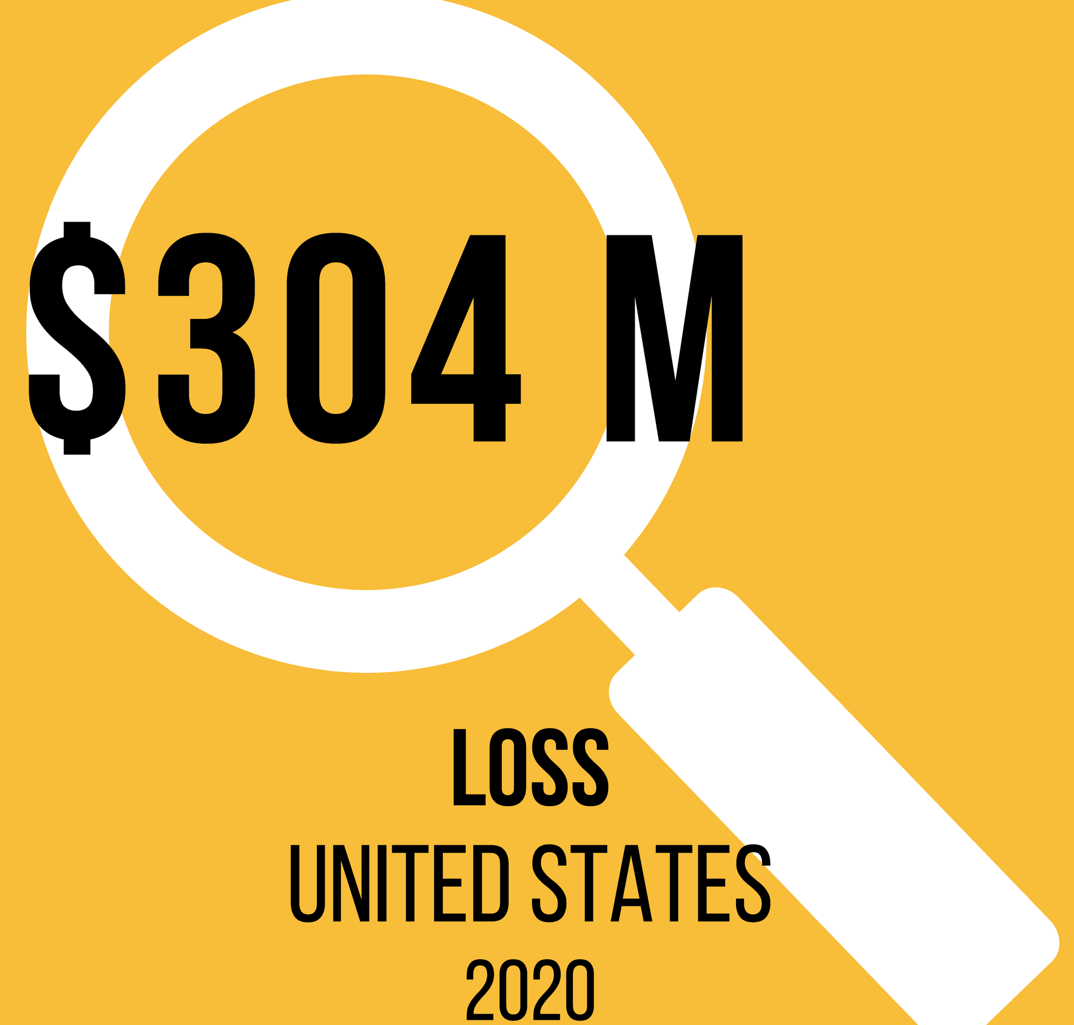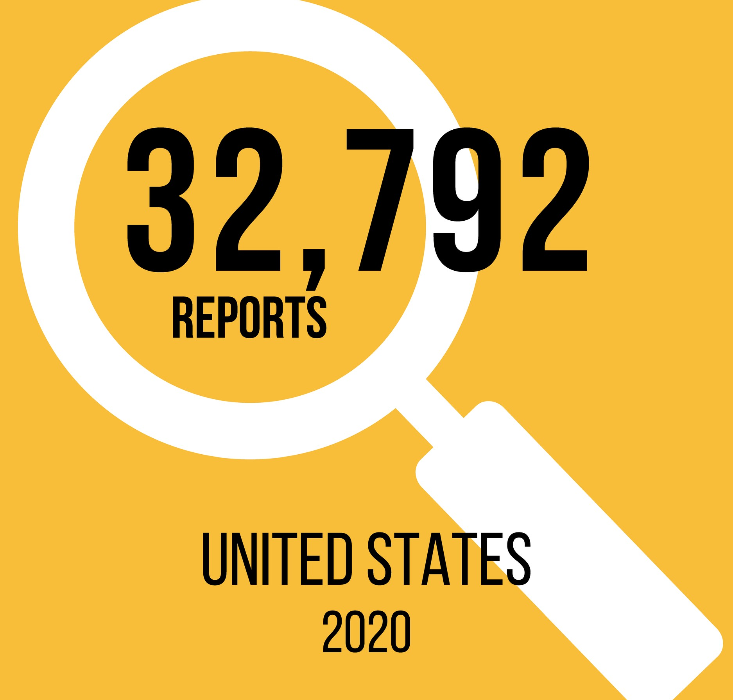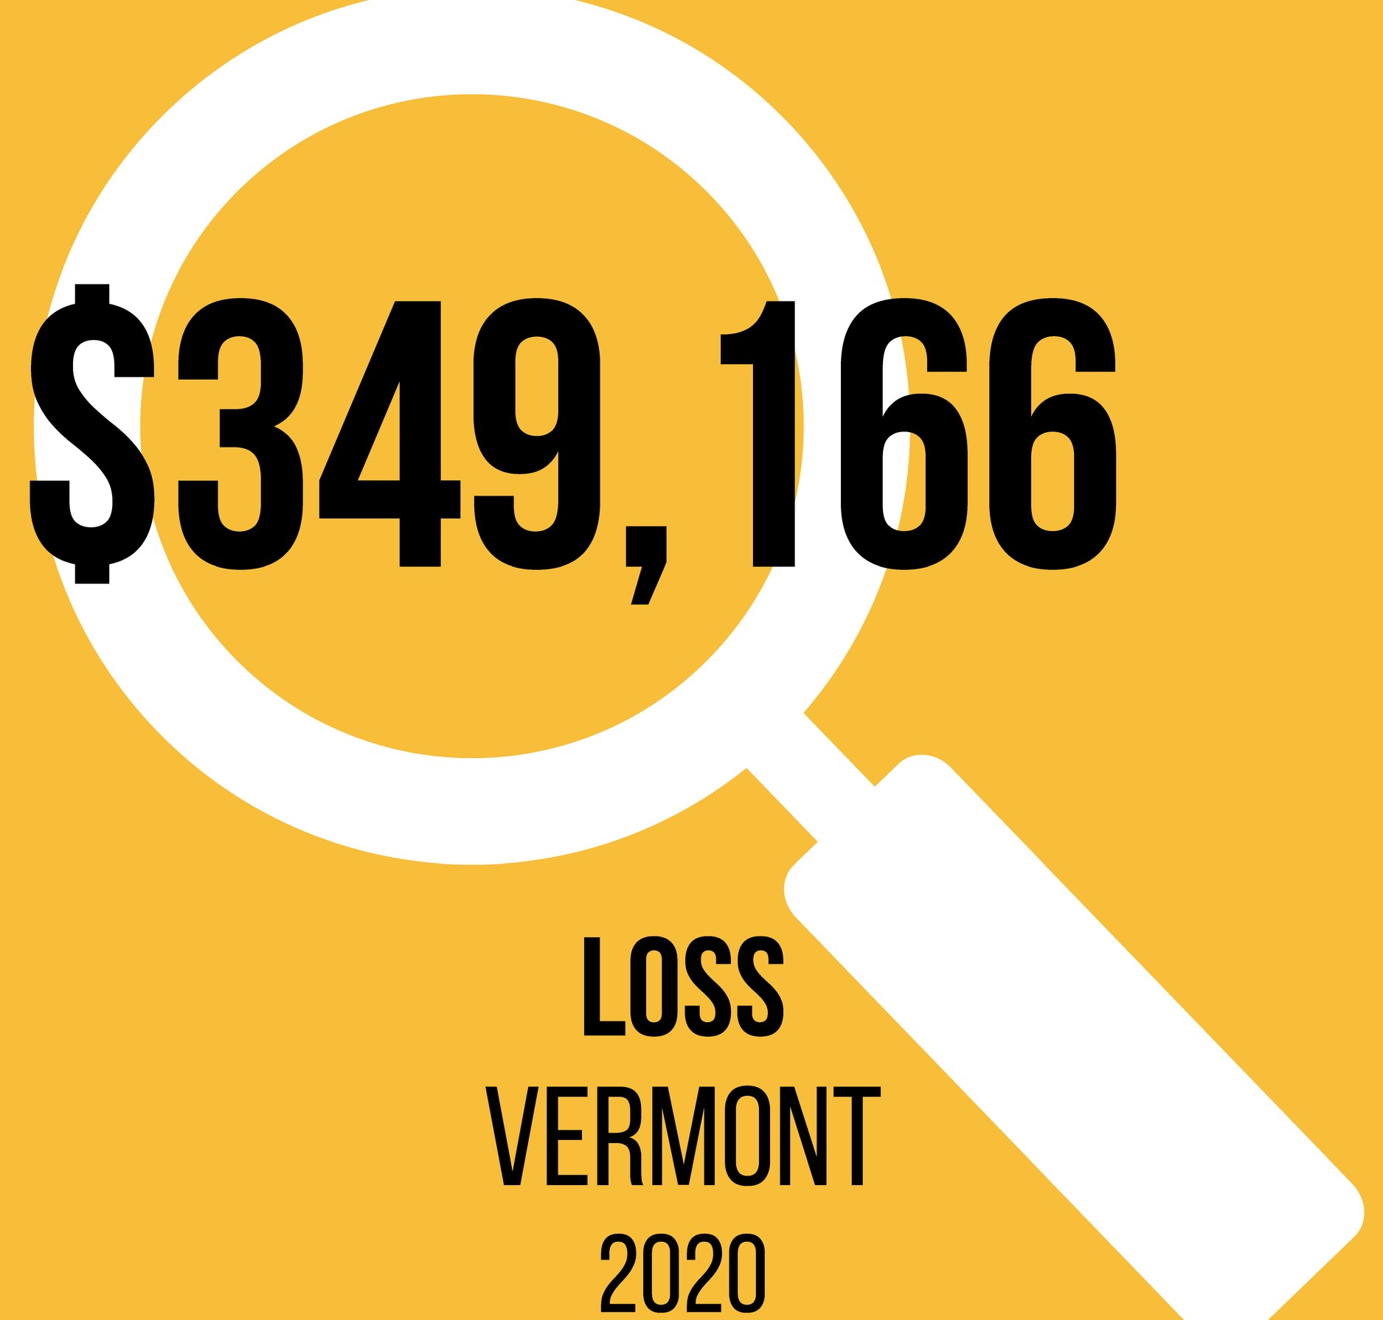Con-artists fabricate a romantic relationship or deep friendship of confidence with a target.
Romance Imposter
K N O W Y O U R R E L A T I O N S H I P S T A K E S T E P S T O V E R I F Y

HOW STEPS TO VERIFY

Trust is formed and a connection is made.
At some point in the relationship, financial help is needed. Caring partners offer funds.
Relationships can last months or years.
Entire savings have been lost. Common forms of payment include wire transfers, gift cards, cash and access to accounts.
Funds sent likely cannot be retrieved.
Identity theft has lasting impact.
- Use reverse image searches to look up images of the person; if there are many results, the contact may be using someone else's image and is a scam.
- Video chat on your terms and at random times. If they are typically unavailable, they may be scamming someone else.
- Use the SLOW method; consult with your close contacts and reach out to an organization in your life who cares. They may spot something you don't.
- Never send money to someone you have not met in person.

CONSUMER ASSISTANCE PROGRAM
A T T O R N E Y G E N E R A L ' S O F F I C E & U N I V E R S I T Y O F V E R M O N T G E T H E L P W I T H C O N S U M E R P R O B L E M S A N D R E P O R T S C A M S
1-800-649-2424
ago.vermont.gov/cap

Go online or scan QR code to watch the Avoiding the Romance Scam video.

