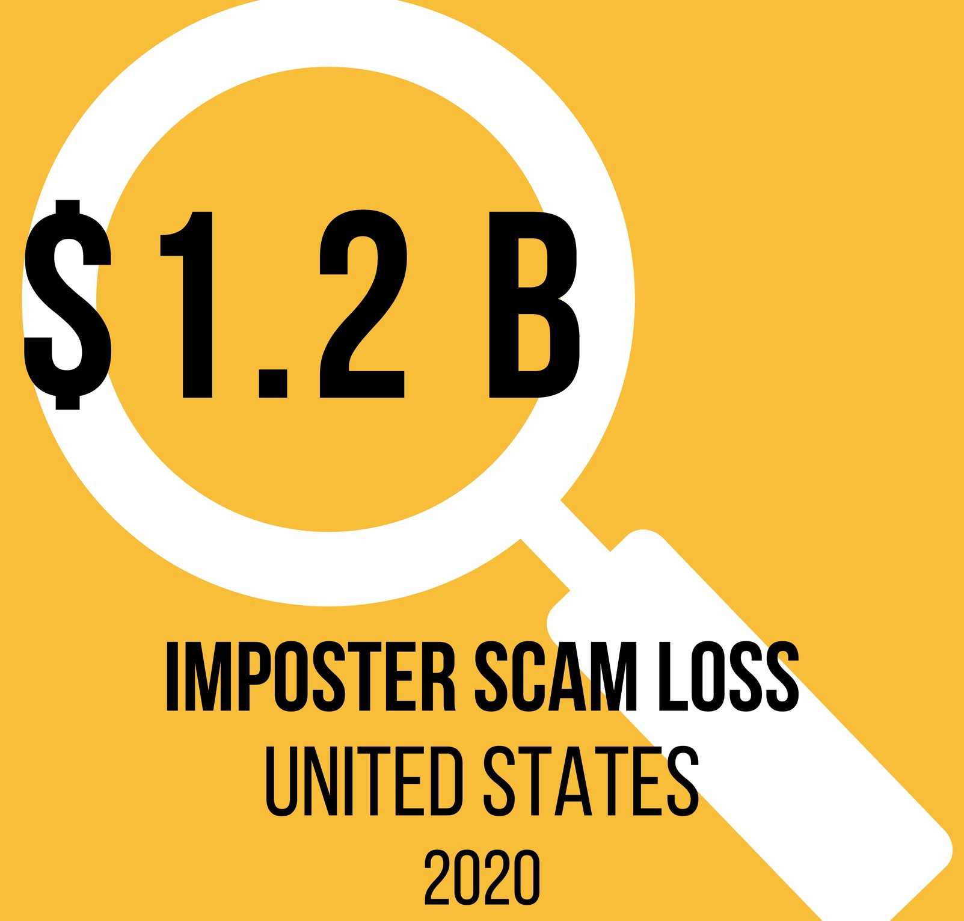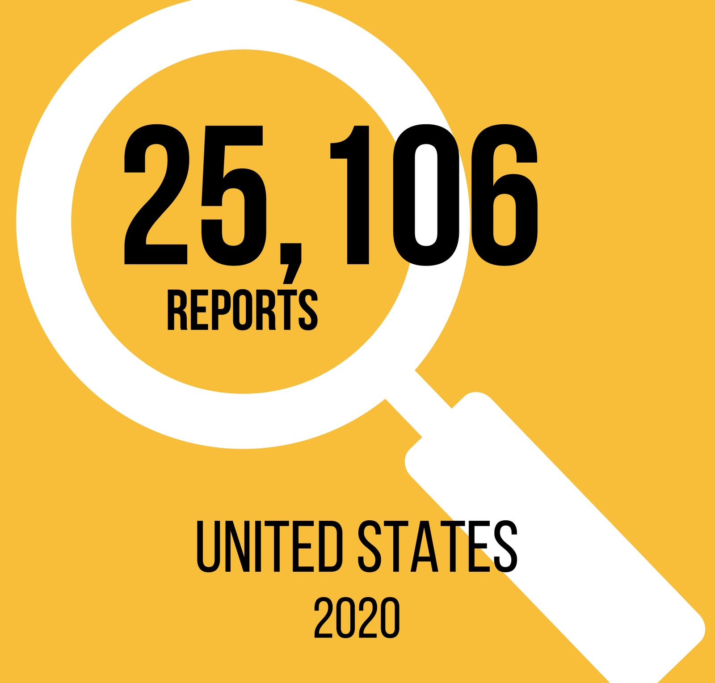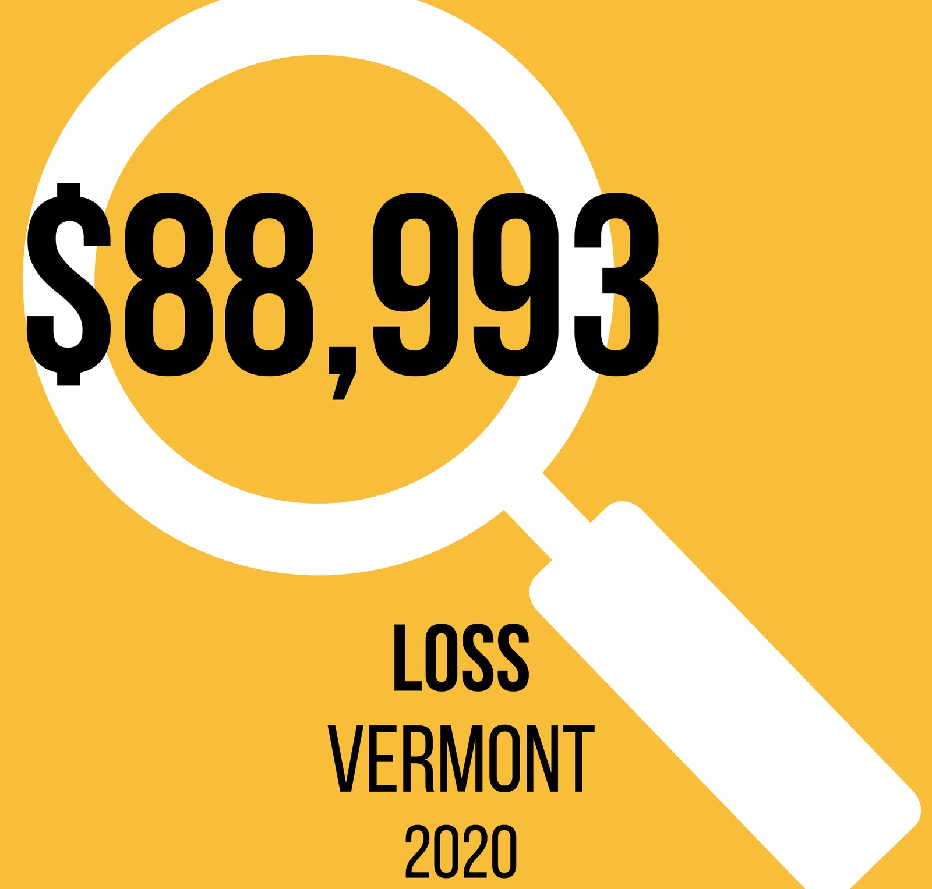A criminal posing as a relative claims to be in trouble and funds are needed immediately.
Family Imposter
K N O W Y O U R R E L A T I O N S H I P S
T A K E S T E P S T O V E R I F Y

HOW STEPS TO VERIFY

Scammers spike your emotional response.
Claims are made that a horrible incident occurred involving a family member.
Contacts are asked to keep the situation private.
Funds are requested urgently to help resolve the emergency.
Common forms of payment include wire transfers, gift cards and cash. Funds sent likely cannot be retrieved.
- Start with the SLOW method: SLOW down, LOG the contact, make ONE call to a primary contact, reach out to an organization in your life WHO cares.
- Keep phone numbers to your trusted family and friends in an easy to locate place, such as near the phone.
- Make up a secret code to use among family members and exchange it during actual family emergencies.
- Never send money to parties you cannot verify.

CONSUMER ASSISTANCE PROGRAM
A T T O R N E Y G E N E R A L ' S O F F I C E & U N I V E R S I T Y O F V E R M O N T G E T H E L P W I T H C O N S U M E R P R O B L E M S A N D R E P O R T S C A M S
1-800-649-2424
ago.vermont.gov/cap

Go online or scan QR code to watch the Avoiding the Family Emergency Scam video.

